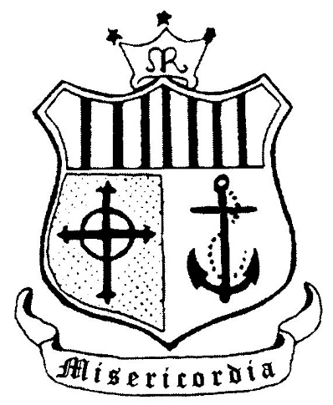

Scoil an Chlochair

*Convent Primary School*

**Covid-19 School Response Plan**

**Updated 22/2/21**

Table of Contents

Introduction 3

1. Convent Primary School COVID-19 Policy 4

2. Planning and Preparing for Return to School 5

3. Procedure for Returning to Work (RTW) 5

4. Return to work safely and Lead Worker Representative 5

5. Safety Statement and Risk Assessment 6

6. General advice to prevent the spread of the virus 6

7. Managing the risk of spread of COVID-19 7

8. Control Measures 8

9. Dealing with a suspected case of Covid-19 11

10. Staff Duties 11

11. Covid related absence management 12

12. Employee Assistance and Wellbeing Programme 12

Appendix 1: Dealing with a suspected case of Covid-19: Isolation Plan 13

Appendix 2: Guidelines issued to SEN staff in advance of SEN classes opening on 22nd February 2021 15

Appendix 3: Use of Staffroom and Covid-19 18

Appendix 4: Useful links for parents & guardians 19

Appendix 5: Wellbeing Links 21

Appendix 6 Checklist for School Management Composite Checklist for Schools 31

Appendix 7 Checklist for dealing with a suspected case of COVID-19 35

Appendix 8 Checklist for Cleaning 37

# Introduction

This *Covid-19 Response Plan* is designed to support the staff and Board of Management (BOM) in putting measures in place that will prevent the spread of Covid-19 in the Convent Primary School

The Covid-19 Response Plan details the policies and practices necessary for a school to meet the Government’s ‘*Return to Work Safely Protocol’*, the Department of Education and Skills plan for school reopening and to prevent the spread of Covid-19 in the school environment. The plan incorporates current advice about measures to reduce the spread of Covid-19 in the community issued by the National Public Health Emergency Team (NPHET).

It is important that the resumption of school-based teaching and learning and the reopening of school facilities comply with the protocol to minimise the risk to students, staff and others. As the advice issued by NPHET continues to evolve, this protocol and the measures management and staff need to address may also change.

The response plan will support the sustainable reopening of our school where the overriding objective is to protect the health of staff and pupils while promoting the educational and development needs of the children in the school.

In line with the Return to Work Safely Protocol, the key to a safe and continued return to work, and re-opening of our schools requires strong communication and a shared collaborative approach between the Board of management, staff, pupils and parents.

This document aims to provide details of:

1. **COVID-19 School Policy**
2. **Planning and Preparing for Return to School** 
   1. **School Building**
   2. **Signage**
3. **Procedure for Returning to Work (RTW)**
4. **Return to work safely and Lead Worker Representative(s**)
5. **Safety Statement and Risk Assessment**
6. **General advice to prevent the spread of the virus**
7. **Managing the Risk of Spread of Covid-19**
   1. **Wash your Hands Frequently**
   2. **Hand Hygiene and Hand Sanitiser**
   3. **Avoid Touching your Eyes, Nose and Mouth**
   4. **Physical Distancing**
   5. **Practice Respiratory Hygiene**
   6. **People at Very High Risk (Extremely Vulnerable)**
8. **Control Measures**
   1. **Return to Work Form**
   2. **Induction Training**
   3. **Induction Training – On-line Video**
   4. **Hygiene and Respiratory Etiquette**
   5. **Personal Protective Equipment (PPE)**
   6. **Wearing of Gloves**
   7. **Cleaning**
   8. **Access to the School Building / Contact Log**
   9. **First Aid / Emergency Procedure**
9. **Dealing with a suspected case of Covid-19**
10. **Staff Duties**
11. **Covid related absence management**
12. **Employee Assistance and Wellbeing Programme**

**Appendices**

The assistance and cooperation of all staff, pupils, parents/guardians, contractors and visitors is critical to the success of the plan.

Every effort is made to ensure the accuracy of the information provided in this document. However, should errors or omissions be identified, please notify us so that appropriate measures can be taken to rectify same.

**Note:** The plan is a live working document and may be reviewed and amended to take into account new guidance from[www.Gov.ie](http://www.gov.ie), [www.dbei.ie](http://www.dbei.ie) [www.hse.ie](http://www.hse.ie), [www.hpsc.ie](http://www.hpsc.ie), [www.hsa.ie](http://www.hsa.ie); [www.education.ie](http://www.education.ie);

# Convent Primary School COVID-19 Policy

This COVID-19 policy outlines our commitment as a school to implement the plan and help prevent the spread of the virus.

The policy will be signed and dated by the Principal and Chairperson of the Board of Management and brought to the attention of staff, pupils, parents and others.

**COVID-19 Policy Statement**

The Convent Primary School is committed to providing a safe and healthy workplace for all our staff and a safe learning environment for all our pupils. To ensure that, we have developed the following COVID-19 Response Plan. The BOM and all school staff are responsible for the implementation of this plan and a combined effort will help contain the spread of the virus. We will:

* continue to monitor our COVID-19 response and amend this plan in consultation with our staff
* provide up to date information to our staff and pupils on the Public Health advice issued by the HSE and Gov.ie
* display information on the signs and symptoms of COVID-19 and correct handwashing techniques
* A Lead Worker Representative who is easily identifiable to carry out the role outlined in this plan has been agreed by staff. A Deputy Lead Worker Representative has also been agreed by staff.
* inform all staff and pupils of essential hygiene and respiratory etiquette and physical distancing requirements
* adapt the school to facilitate physical distancing as appropriate in line with the guidance and direction of the Department of Education
* keep a contact log to help with contact tracing
* ensure staff engage with the induction / familiarisation briefing provided by the Department of Education
* implement the agreed procedures to be followed in the event of someone showing symptoms of COVID-19 while at school
* provide instructions for staff and pupils to follow if they develop signs and symptoms of COVID-19 during school time
* implement cleaning in line with Department of Education advice

All school staff will be consulted on an ongoing basis and feedback is encouraged on any concerns, issues or suggestions.

This can be done through the Lead Worker Representative(s), who will be supported in line with the agreement between the Department and education partners.

Signed: ____________________ Date: _____________________

# Planning and Preparing for Return to School

The Board of Management aims to facilitate the resumption of school-based teaching and learning and the return to the workplace of staff. The return to the work must be done safely and in strict adherence to the advice and instructions of public health authorities and the Government.

Details for the reopening of the school facility and the applicable controls are outlined in this document.

1. ***School Buildings***

Prior to the re-opening the school after the January 2021 closure, the following will be checked:

* Flushing of the water system at outlets, following low usage to prevent Legionella disease;
* School equipment and mechanical ventilation will be checked for signs of deterioration or damage before being used again;
* That refuse collections and other essential services have resumed

1. ***Signage***

Schools are be required to display signage outlining the signs and symptoms of COVID-19 and to support good hand and respiratory hygiene. The following is a link to the dedicated area of the Health Protection and Surveillance Centre (HPSC) website where there are a number of posters, including those appropriate for primary school pupils, located. Irish versions are also available here

<https://www.hpsc.ie/a-z/respiratory/coronavirus/novelcoronavirus/posters/>These posters have been downloaded and displayed in prominent areas such as offices, corridors, staffroom area, classrooms and toilets.

# Procedure for Returning to Work (RTW)

In order to return to the workplace, staff must complete a **Return to Work (School) [RTW(s)]** form, which is available electronically or from the Principal. A RTW form should only be completed **at least 3 days** prior to any proposed date of return to the workplace. See Appendix 1.

On receipt of the completed form the Principal will provide: details of the **Induction Training** for completion by staff prior to the return to the workplace and details of any additional health and safety measures in place in the school to facilitate the staff member’s return to the school facility.

**Note: Induction Training for staff has been developed by the Department in consultation with stakeholders and has been made available for all schools and staff.**

# Return to work safely and Lead Worker Representative

Responsibility for the development and implementation of the Covid-19 Response Plan and the associated control measures lies primarily with the Board of Management and the School Leadership.

The Return to Work Safely protocol provides for an agreed procedure between management and staff to appoint a Lead Worker Representative to carry out a specific role.

**Note: The process for appointment of the Lead Worker representative in schools has been agreed centrally between the Department of Education and Skills and the education partners. That process, has been circulated to all schools in advance of the re-opening of schools.**

The role of the worker representative is to ensure that Covid-19 measures are adhered to in the workplace as follows

* Work collaboratively with the employer to ensure, so far as is reasonably practicable, the safety, health and welfare of employees in relation to COVID-19.
* Promote good hygiene practices such as washing hands regularly and maintaining good respiratory etiquette along with maintaining social distancing in accordance with public health advice.
* Assist with the implementation of measures to suppress COVID-19 in the workplace.
* Monitor adherence to measures put in place to prevent the spread of COVID-19.
* Consult with colleagues on matters relating to COVID-19 in the workplace.
* Make representations on behalf of their colleagues on matters relating to COVID-19 in the workplace.

If a staff member has any concerns or observations in relation to the Covid-19 Response Plan and control measures or the adherence to such control measures by staff, parents/guardians, contractors or visitors, he/she should contact the lead worker(s) who will engage with the Principal/BOM.

|  |
| --- |
| Name of Lead Worker Representative: |
| Jennifer O’Farrell |
| Assistant Lead Worker Representative: |
| Eimear Buckley |

All staff, parents/guardians, contractors and visitors have a responsibility both as individuals and collectively to have due regard for their own health and safety and that of others and to assist with the implementation of the Covid-19 Response Plan and associated control measures.

# Safety Statement and Risk Assessment

COVID-19 represents a hazard in the context of health and safety in the school environment. IPPN has commissioned an independent Policy Statement and Risk Assessment to identify the control measures required to mitigate the risk of COVID-19 in school settings.

We will continue to regularly review our emergency procedures involving, fire safety, first aid, accidents and dangerous occurrences to consider any new risks that arise due to the COVID-19 School Response Plan. Any changes to the schools existing emergency procedures will be documented.

Existing risk assessments will be reviewed on an ongoing basis to consider any new risks that arise due to the school’s COVID-19 Response Plan. Any changes to the school’s current risk assessments will also be documented.

# General advice to prevent the spread of the virus

In order to prevent the spread of COVID-19 it is important to know and recognise the symptoms. They are:

* High temperature
* Cough
* Shortness of breath or breathing difficulties
* Loss of smell, of taste or distortion of taste

The best way to prevent the spread of COVID-19 in a school is to minimise the risk of introduction of the disease into the school setting in the first place. This can be achieved through the following measures:

* Promote awareness of COVID-19 and its symptoms amongst staff, pupils, parents and visitors.
* Advise staff and parents of pupils who have symptoms of COVID-19 or other acute infectious diseases not to attend school, to phone their GP and follow the HSE guidance on self-isolation.
* Advise staff and parents of pupils who have been identified by the HSE as contact of a person with COVID-19 not to attend schools and to follow the HSE advice on restriction of movement.
* Ensure that staff and pupils know what to do if they develop symptoms at school.
* Everyone entering the school building should be required to perform hand hygiene with hand sanitiser.
* Visitors to school during the day should be by prior arrangement and should be received at a specific contact point.

Staff, pupils and visitors should at all times adhere to the up to date advice and instructions of the public health authorities in relation to protecting oneself and others against the risk posed by the Covid-19 virus.

Updated advice from the HSE is available on its website – <https://www2.hse.ie/coronavirus/> The Department of Education and Skills will ensure all updated advice is circulated to schools. The Convent Primary School will circulate this information to staff, pupils and visitors in a timely manner.

# Managing the risk of spread of COVID-19

1. ***Wash your Hands Frequently***

Regular hand washing with soap and water is effective for the removal of COVID-19.

Follow the HSE guidelines on handwashing. For advice from HSE on how to wash your hands the following link will be helpful: <https://www2.hse.ie/wellbeing/how-to-wash-your-hands.html>

1. ***Hand Hygiene and Hand Sanitisers***

Hand hygiene can also be achieved by the use of a hand sanitiser (when hands are clean).

Hand sanitisers are more readily deployed in our school setting to avoid disruption to teaching and learning and to avoid congestion of staff and pupils waiting to use hand washing facilities.

They will be available at entry and exit points and in each classroom. Alcohol-based sanitiser will not be stored or used near heat or naked flame.

1. ***Avoid Touching Eyes, Nose and Mouth***

Why? Hands touch many surfaces and can pick up viruses. Once contaminated, hands can transfer the virus to your eyes, nose or mouth.

1. ***Physical Distancing***

Physical distancing is recommended to reduce the spread of infection in the workplace.

**Note: Guidance on the physical distancing requirements will be informed by public health advice for schools.** Where possible staff should maintain a minimum of 1m distance and where possible 2m. Measures (where possible) should also be taken to avoid close contact at face to face level such as remaining standing rather than sitting beside/crouching down.

1. ***Practice respiratory hygiene***

Make sure you, and the people around you, follow good respiratory hygiene. This means covering your mouth and nose with a tissue or your bent elbow when you cough or sneeze. Then dispose of the used tissue immediately.

By following good respiratory hygiene, you protect the people around you from viruses such as cold, flu and Covid-19.

Good hygiene practices and washing your hands properly and regularly can help stop the spread of the virus. It is, therefore, crucial that all staff adhere to this advice and adopt the following practices as strictly as possible.

1. ***Do***

* Wash your hands properly and often
* Cover your mouth and nose with a tissue or your sleeve when you cough and sneeze
* Put used tissues into a bin and wash your hands
* Clean and disinfect frequently touched objects and surfaces

1. ***Do Not***

* Touch your eyes, nose or mouth if your hands are not clean
* Share objects that touch your mouth – for example, bottles, cups, cutlery, etc.

1. ***People at Very High Risk (Extremely Vulnerable):***

Current public health guidelines have identified groups who are defined as being at very high risk. The HSE has set out these groups, which include people who:

The list of people in very high-risk groups include people who:

* are over 60 years of age - even if you're fit and well
* have had an organ transplant
* are undergoing active chemotherapy for [cancer](https://www2.hse.ie/conditions/coronavirus/cancer-patients.html)
* are having radical radiotherapy for lung cancer
* have cancers of the blood or bone marrow such as leukaemia, lymphoma or myeloma who are at any stage of treatment
* are having immunotherapy or other continuing antibody treatments for cancer
* are having other targeted cancer treatments which can affect the immune system, such as protein kinase inhibitors or PARP inhibitors
* have had bone marrow or stem cell transplants in the last 6 months, or who are still taking immunosuppression drugs
* severe respiratory conditions including cystic fibrosis, [severe asthma](https://www2.hse.ie/conditions/coronavirus/asthma.html), pulmonary fibrosis, lung fibrosis, interstitial lung disease and [severe COPD](https://www2.hse.ie/conditions/coronavirus/copd.html)
* have a condition that means you have a very high risk of getting infections (such as SCID, homozygous sickle cell)
* are [taking medicine that makes you much more likely to get infections](https://www2.hse.ie/conditions/coronavirus/weak-immune-system.html) (such as high doses of steroids or immunosuppression therapies)
* have a serious heart condition and you are pregnant

The advice for this group is available from the HSE. Staff who are in this group should self-declare on the Return to Work form if they believe that they are at very high risk. Details of the leave arrangements that will apply will be updated by the Department of Education and Skills.

If the Board/Principal is unsure whether or not staff fall into the very high-risk category, advice will be sought from the Occupational Health Service.

# Control Measures

A range of essential control measures have been implemented to reduce the risk of the spread of Covid-19 virus and to protect the safety, health and welfare of staff, pupils, parents/guardians and visitors as far as possible within the school.

These control measures are outlined in this document. The control measures shall continue to be reviewed and updated as required on an ongoing basis. It is critical that staff, pupils, parents/guardians and visitors are aware of, and adhere to, the control measures outlined and that they fully cooperate with all health and safety requirements.

*Staff, in particular, should note that they have a legal obligation under Section 13 of the Safety, Health and Welfare at Work Act 2005 to comply with health and safety requirements and to take reasonable care for the health and safety of themselves, their colleagues and other parties within the workplace.*

**Infection Prevention Control Measures- To Prevent Introduction & Spread of Covid-19 in Schools:**

Staff and pupils may not return to school or attend school in the event of the following:

* if they are identified by the HSE as a close contact of a confirmed case of Covid-19
* if they live with someone who has symptoms of the virus
* if they have travelled outside of Ireland; in such instances staff are advised to consult and follow latest Government advice in relation to foreign travel.
* staff and pupils are required to co-operate with any public health officials and the school for contact tracing purposes and follow any public health advice in the event of a case or outbreak in the school.

The following control measures have been put in place:

1. ***Return to Work Form***

Staff will be required to complete a RTW form at least 3 days prior to any return to the school facility (see section 2 above). The purpose of the RTW form is to get confirmation from staff that, to the best of his/her knowledge, he/she has no symptoms of Covid-19 and is not self-isolating or cocooning or awaiting the results of a Covid-19 test. Staff are requested to confirm (verbally or in writing) that the details in the pre-return to work form remain unchanged following subsequent periods of closure such as school holidays.

**Procedure for Returning to Work (RTW):**

1. ***Induction Training***

All staff will undertake and complete the following Covid-19 Induction Training <https://www.gov.ie/en/publication/dd7fb-induction-training-for-reopening-schools/> prior to returning to the school building. The aim of such training is to ensure that staff have full knowledge and understanding of the following:

* Latest up to-date advice and guidance on public health
* Covid-19 symptoms
* What to do if a staff member or pupil develops symptoms of Covid-19 while at school
* Outline of the Covid-19 response plan

Staff will be kept fully informed of the control measures in place in the school and their duties and responsibilities in preventing the spread of Covid-19 and with any changes to the control measures or guidance available from the public health authorities.

If a staff member is unsure about any aspect of the Covid-19 Response Plan, the associated control measures, or his/her duties, he/she should immediately seek guidance from the LWR, DLWR or Principal.

1. ***Induction Training for Return to School***

**Induction Training for reopening schools in the new school year (2021) has been developed by the Department in consultation with stakeholders and has been made available to all schools and staff.**

1. ***Hygiene and Respiratory Etiquette***

It is crucial that all staff, pupils, parents/guardians, contractors and visitors are familiar with, and adopt, good hand and respiratory hygiene practices.

Guidance documentation and Information posters are available at various locations within the school facility. Information posters will be prominently displayed at appropriate locations within the school facility including offices, corridors, staffroom area, classrooms and toilet areas. Such are intended to inform but also remind everyone about the importance of hygiene in preventing the spread of Covid-19 virus and protecting health and safety.

Handwashing facilities and/or hand sanitisers are available at multiple locations within the school facility and are be available in each classroom. Staff and pupils are required to wash or sanitise their hands when entering and exiting vehicles and when entering and exiting school buildings.

1. ***Use of Personal Protective Equipment (PPE)***

PPE is required to be worn within the school facility according to current occupational and public health guidance. Visors and surgical grade masks are provided for all staff. For a limited number of staff, additional PPE such as aprons, gowns and gloves will be required to be used occasionally or constantly due to the nature of certain work activities.

Such include roles where:

* Performing intimate care
* Where a suspected case of Covid-19 is identified while the school is in operation

Appropriate PPE will be available for dealing with suspected COVID-19 cases, intimate care needs and for first aid. This will be updated in line with advice from the HPSC (Health Protection Surveillance Centre)

Where staff provide healthcare to children with medical needs in the school environment they should apply standard precautions as per usual practice.

The use of a face covering will conceal facial expression and can make communication difficult and as such may not be practical in a school setting. However, the wearing of a visor as an alternative to a facial covering may be considered where there is a concern that physical distancing cannot be maintained, there will be prolonged close contact and/or that exposure to fluid/respiratory droplets is likely.

1. ***Wearing of Gloves:***
2. Routine use of disposable gloves is not a substitute for hand hygiene. The use of disposable gloves in the school setting by pupils or staff is not appropriate. It does not protect the wearer and may expose others to risk from contaminated gloves.
3. ***Cleaning***

Arrangements for more regular and thorough cleaning of areas and surfaces within the school have been made.

Regular and thorough cleaning of communal areas and frequently touched surfaces shall be conducted, in particular, toilets, lifts, door handles and kitchens. Cleaning will be performed regularly and whenever facilities or surfaces are visibly dirty.

All staff will have access to cleaning products and will be required to maintain cleanliness of their own work area. Under no circumstances should these cleaning materials be removed from the building.

Staff should thoroughly clean and disinfect their work area before and after use each day.

There will be regular collection of used waste disposal bags from offices and other areas within the school facility**.**

Shower facilities shall not be available for use by staff or pupils due to the increased risk associated with communal shower facilities and areas. This shall be reviewed in line with government guidance.

**Staff must use and clean their own equipment and utensils (cup, cutlery, plate etc.).**

1. ***Access to the school building /contact log***

Access to the school facility will be in line with agreed school procedures. All staff will sign in digitally using a fob system.

Arrangement for necessary visitors such as contractors and parents/guardians with be restricted to essential purposes and limited to those who have obtained prior approval from the Principal.

The prompt identification and isolation of potentially infectious individuals is a crucial step in restricting the spread of the virus and protecting the health and safety of the individuals themselves and other staff, contractors and visitors at the workplace. A detailed sign in/sign out log of those entering the school facilities should be maintained. The school will maintain a log of staff and students contacts. Click here to download a copy of the Contact Tracking Log

1. ***First Aid/emergency procedure***

The standard First Aid/Emergency procedure shall continue to apply in the Convent Primary School.

In an emergency or in case of a serious incident, call for an ambulance or the fire brigade on 112/999

Contact the principal or nearest first aider giving details of location and type of medical incident.

1. ***Ventilation***: The Department has published guidance setting out the practical steps for good ventilation in accordance with public health advice ‘Practical Steps for the Deployment of Good Ventilation Practices in Schools’. The guidance sets out an overall approach for schools that windows should be open as fully as possible when classrooms are not in use (e.g. open for at least 15 minutes if possible, during break times (assuming not in use) and also at the end of each school day) and partially open when classrooms are in use. The guidance provides that good ventilation can be achieved in classrooms without causing discomfort, particularly during cold weather. Rooms should be well ventilated before occupancy each day. This can be achieved by ensuring that at the end of the school day each evening, the windows in each room should be opened (as wide as practical and safe while also considering security issues) for at l***east 15 minutes*** to ventilate the room fully. Keeping open the internal doors into classrooms for periods of time may assist with increasing air movement and ventilation rate. It is important to note that fire doors should not be kept open unless fitted with approved automatic closers so that they function as fire doors in the event of an alarm of fire. Ventilation will be provided through open windows in areas such as the gym, toilets, sensory room, staff rooms, office.

# Dealing with a suspected case of Covid-19

Staff or pupils should not attend school if displaying any symptoms of Covid-19. The following outlines how the Convent Primary School will deal with a suspected case that may arise during the course of work.

A designated isolation area has been identified within the school building. The possibility of having more than one person displaying signs of Covid-19 has been considered and a contingency plan for dealing with additional cases has been put in place. The designated isolation area is behind a closed door and away from other staff and pupils.

If a staff member/pupil displays symptoms of Covid-19 while at work in the Convent Primary School, the following are the procedures to be implemented:

* If the person with the suspected case is a pupil, the parents/guardians should be contacted immediately
* Isolate the person and have a procedure in place to accompany the individual to the designated isolation area via the isolation route, keeping at least 2 metres away from the symptomatic person and also making sure that others maintain a distance of at least 2 metres from the symptomatic person at all times
* Provide a mask for the person presenting with symptoms. He/she should will wear the mask until they have returned home.
* Assess whether the individual who is displaying symptoms can immediately be directed to go home/be brought home by parents and call their doctor and continue self-isolation at home
* The individual should avoid touching people, surfaces and objects. Advice should be given to the person presenting with symptoms to cover their mouth and nose with the disposable tissue provided when they cough or sneeze and put the tissue in the waste bag provided
* If the person is well enough to go home, arrange for them to be transported home by a family member, as soon as possible and advise them to inform their general practitioner by phone of their symptoms. Public transport of any kind should not be used
* If they are too unwell to go home or advice is required, contact 999 or 112 and inform them that the sick person is a Covid-19 suspect.
* Carry out an assessment of the incident which will form part of determining follow-up actions and recovery
* Arrange for appropriate cleaning of the isolation area and work areas involved.
* Jennifer O’Farrell LWR/Eimear Buckley DLWR are responsible for ensuring that all aspects of the protocol to deal with suspected cases have been adhered to.

The HSE will inform any staff/parents who have come into close contact with a diagnosed case via the contact tracing process. The HSE will contact all relevant persons where a diagnosis of COVID-19 is made. The instructions of the HSE should be followed and staff confidentiality is essential at all times. Staff are encouraged to download the HSE Covid-19 Tracker App to assist Public Health for contact tracing purposes both in and out of the school setting.

# Staff Duties

Staff have a statutory obligation to take reasonable care for their own health and safety and that of their colleagues and other parties. In order to facilitate a safe return to work, these duties include, but are not limited to, the following:

* Adhere to the School Covid-19 Response Plan and the control measures outlined. The cooperation and assistance of all staff is essential to reduce the risk of spread of Covid-19 and to protect health and safety as far as possible within the school. All staff have a key role to play.
* Coordinate and work with their colleagues to ensure that physical distancing is maintained
* Make themselves aware of the symptoms of Covid-19 and monitor their own wellbeing
* If a staff member displays any symptoms of Covid-19 they are required to self-isolate, restrict their movements at home and need to contact their GP promptly to arrange a test. Staff may not return or attend school if they have symptoms of Covid-19 under any circumstances.
* If a staff member develops any symptoms of Covid-19 whilst within the school facility, they should adhere to the procedure outlined above
* Complete the RTW form before they return to work
* Must inform the Principal if there are any other circumstances relating to Covid-19, not included in the form, which may need to be disclosed to facilitate their safe return to the workplace
* Must complete Covid-19 Induction Training and any other training required prior to their return to school
* Must be aware of, and adhere to, good hygiene and respiratory etiquette practices
* Keep informed of the updated advice of the publ**ic** health authorities and comply with same.
* Cooperate with any Public Health personnel and their school for contact tracing purposes and follow any public health advice given in the event of a case or outbreak in the school.
* Undergo any Covid-19 testing that may be required as part of a mass or serial testing as advised by Public Health.

***Staff may not return to or attend school in the case of the following:***

-if they are identified by the HSE as a close contact of a confirmed case of Covid-19

-if they live with someone who has symptoms of the virus

-if they have travelled outside of Ireland; in such instances staff are advised to consult and follow latest Government advice in relation to foreign travel.

# Covid related absence management

The management of a Covid-19 related absence will be managed in line with agreed procedures with DES.

# Employee Assistance and Wellbeing Programme

The Board of Management aims to protect and support the health and wellbeing of all staff (physical, mental, spiritual etc.) both at work, whether in the school facility or at home and outside of work. The Board of Management is mindful that the support and promotion of staff health and wellbeing is particularly important in the current context where the Covid-19 pandemic has caused considerable challenges for, and disruption to, people’s personal, family and social lives as well as their work arrangements.

The Board of Management aims to foster a culture and work environment that support healthy behaviours and staff wellbeing and shall continue to make health and wellbeing tools and guidance available to staff as well as organising suitable support programmes, initiatives and events.

These are challenging times for everyone. Should a staff member experience any stress or anxiety in respect of work or work arrangements, he/she should feel free to speak to the principal.

The EAS is accessible through the dedicated **Free-phone Confidential Helpline** at **1800 411 057** and is available 24 hours a day, 365 days a year. Alternatively, text ‘Hi’ to 087 369 0010 to avail of EAS support on SMS & WhatsApp**.**

Employees can access the Spectrum Life wellbeing portal as follows:

* Sign Up link at: <https://wellbeingtogether.spectrum.life/login?org=ylVIIU17>
* Organisation code will be pre-populated. If not, organisation code is ylVIIU17
* Log in thereafter at: <https://wellbeingtogether.spectrum.life/login>

# Appendix 1: Dealing with a suspected case of Covid-19: Isolation Plan

Staff members will manage suspected cases in line with the HSE and DES protocols and training. Principal Sheila O’Connor and Deputy Principal Jennifer O’Farrell have been nominated as the members of the school management team who are responsible for ensuring that all aspects of the protocol to deal with suspected cases have been adhered to.

**Isolation Area**

Our isolation area is the Sunflower Room on the 1945 corridor. The Sunflower Room has a door that closes and has a number of windows. It is an independent room which is accessible to staff and pupils including those with disabilities. The room is spacious so it can accommodate more than one suspected case of COVID-19. The route to the isolation area is accessible via the 1910 and 1945 corridors. The following are available in the isolation room:

* Tissues
* Hand sanitiser
* Disinfectant/wipes
* Gloves/Masks/Visor
* Plastic aprons
* Waste bags
* Bins
* Thermometer

**Isolating a Person: Procedure for accompanying the suspected infected person to the isolation area**

The person in charge (usually) Sheila O’Connor, Principal or Jennifer O’Farrell, Deputy Principal should be contacted if a person has any of the four symptoms of Covid-19 i.e.:

* Any new cough,
* a temperature of 38C or higher,
* loss of taste or smell,
* difficulty breathing

The suspected infected person will be accompanied to the Sunflower Room via the shortest possible route which is dependent upon the location of the person. The individual(s) accompanying will maintain physical distancing from the suspected infected person. Where possible a distance of at least 2m from the affected person should be maintained at all times.

The affected person is required to wear a mask whilst in the common area and when exiting the building. The person(s) accompanying the affected person will also wear a mask and their temperature may be measured. The windows in the isolation room will be remain open while the room is in use. The identity of this affected person will remain confidential. All incidents will be logged by school management.

**Arranging for the affected person to leave the school**

If the affected person is a staff member it will be established if they feel well enough to travel home. If staff member is unable to travel home independently their emergency contact person or a person nominated by them will be contacted to escort them home. If the affected person is a pupil their parents/guardians will be contacted immediately and arrangements will be made for their child to be collected. Under no circumstances can an individual use public or school transport to travel home if they are a suspected case of COVID-19.

The affected person will be advised:

* to continue wearing the face mask until they reach home
* to cover their mouth and nose with disposable tissue(s) when they cough or sneeze,
* not use public transport
* to contact their GP for further guidance

**Follow up**

Parents/Guardians will have to complete a return to school form prior their child returning to school. This form is on our school app. The school will liaise with the HSE where necessary.

**Cleaning of the Isolation Area**

The isolation area will be out-of-use until cleaned and disinfected as soon as practical. The area(s) where the staff or pupil were located will also be cleaned and disinfected. The other pupils may have to relocate to the yard or hall while their room is being disinfected. Both rooms will be ventilated.

# Appendix 2: Guidelines issued to SEN staff in advance of SEN classes opening on 22nd February 2021

* Please familiarise yourself with the attached school guidelines for use of staff rooms during Covid-19. For the interim period, Carmel, Dave and staff in Junior ASD will use the main staff room, LR1 staff (including Aoife D.) will use the Cookery Room, Senior ASD staff will use the adjoining shared area and Early Intervention break area remains unchanged.
* **\*NB** *Masks and visors should be donned and doffed and disposed of as demonstrated in videos available at <https://www.hpsc.ie/a-z/respiratory/coronavirus/novelcoronavirus/guidance/infectionpreventionandcontrolguidance/ppe/>

[Face coverings](https://youtu.be/CcFmxdLg5dI)

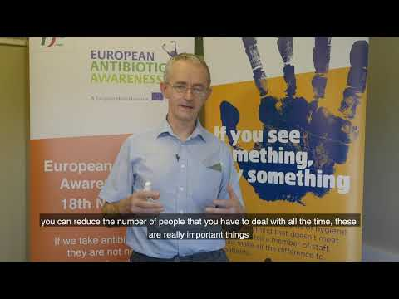

[How to wear a face covering](https://youtu.be/7i2tboLFjbI)

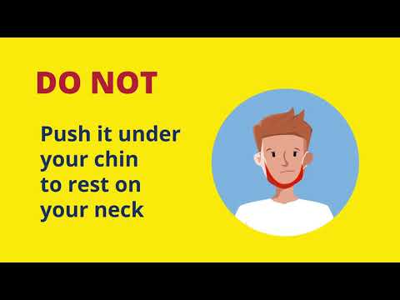

* Masks should be removed and disposed of if they are wet or damaged. Masks should be removed and disposed of if going or a break or visiting the toilet.
* All staff have been issued with tissues and personal sanitisers with clips. These have been left for you in your classroom.
* Each class has been provided with a box of surgical masks for staff use.
* Each class has been provided with a box of tissues
* Staff classed as high risk have been provided with FFP2/FFP3 masks. These can be found in your classroom/work area.
* A laminated copy of the recommended steps to follow when using alcohol rub has been issued to all classes. Please display in a prominent area in your class. These signs are also displayed in staff rooms.
* Photocopiers need to be cleaned before and after use. Antibacterial wipes and bins have been provided at all photocopiers.
* Disposable aprons and gloves are provided in all SEN toilets for the provision of intimate care. We are awaiting a delivery of the shoe coverings. We are still awaiting one dispenser for aprons for Senior ASD toilets.
* Should you require an additional visor for the provision of intimate care/toileting, please contact Jennifer O’Farrell or Sheila O’Connor
* Surgical gowns have been distributed to staff members that requested same. We are currently sourcing disposable aprons with sleeves. Availability of same continues to be a problem.
* Each SEN class has been provided with an ozone machine. Please retain the pack containing the instructions carefully and out of reach of children. This pack also contains an adaptor plug, the devices remote control and safety signage, therefore safekeeping of same is vital. It is the responsibility of the cleaning staff to operate the ozone machines (after daily cleaning) for the interim period.
* Cleaning staff will be using the Zoono spray on all areas of high use every 28-30 days.
* All sanitisers and soap dispensers have been filled and should be in working order. If any are giving trouble/not working properly please let Jennifer O’Farrell or Sheila know.
* Should you require a re-stock of any items please contact Jennifer O’Farrell or Sheila.
* where possible staff should maintain a minimum of 1m distance and where possible 2m. Measures (where possible) should also be taken to avoid close contact at face-to-face level such as remaining standing rather than sitting beside/crouching down.
* Please familiarise yourself with the most recent Department of Education guidelines regarding ventilation: <https://assets.gov.ie/85177/d9643a37-5254-483e-a72e-d2a08ae36d46.pdf>

**Staff toilet allocation for the interim period:**

*1945 toilets*: Junior ASD staff, LR1 staff

*1975 toilet*: Senior ASD staff

Children's toilets 1975 block: Dave, Carmel, Jen O'F , Sheila

*Early Intervention staff toilet*: as normal

**Photocopier allocation for the interim period:**

*Staff room*: Junior ASD class

*Eimear/Aoife's shared area:* LR1 (access via Nóirín's room)

*Senior ASD Shared area:* Senior ASD Class, Early Intervention

17th February 2021.

# Appendix 3: Use of Staffroom and Covid-19

* The windows in the staffroom should remain open during school hours to facilitate adequate ventilation.
* Please sanitise upon entry to and exit from the staffroom.
* Please adhere to social distancing guidelines when and where possible.
* Masks should only be removed in the staff room for the purposes of eating and drinking. Masks should be worn at all other times.
* Staff are encouraged to bring their own cutlery and crockery.
* Please use the antibacterial wipes provided to disinfect the exterior of any appliances you may touch or use e.g. Burco boiler, microwave, toaster.
* Please disinfect your table space using antibacterial spray and blue roll before leaving.
* Please remember to change your mask after taking a break or visiting the toilet.
* Any masks that are wet or damaged masks should be disposed of.

# Appendix 4: Useful links for Parents & Guardians

Protecting your child from Covid-19:

<https://www2.hse.ie/conditions/coronavirus/protecting-your-child.html>

When it’s ok to send your child to school:

<https://www2.hse.ie/conditions/coronavirus/school-and-covid-19/when-it-s-ok-to-send-your-child-to-school-or-childcare.html>

When you should keep your child at home:

<https://www2.hse.ie/conditions/coronavirus/school-and-covid-19/when-you-should-keep-your-child-home.html>

If your child has symptoms of Covid-19:

<https://www2.hse.ie/conditions/coronavirus/children-and-covid-19/if-your-child-has-symptoms-of-covid-19.html>

If your child is a close contact of Covid-19 at school:

<https://www2.hse.ie/conditions/coronavirus/school-and-covid-19/if-your-child-is-a-close-contact-of-covid-19-in-school.html>

[Parent’s Guide: if your child is a close contact of COVID-19 in school](https://youtu.be/x2Vur9Dx4dk)

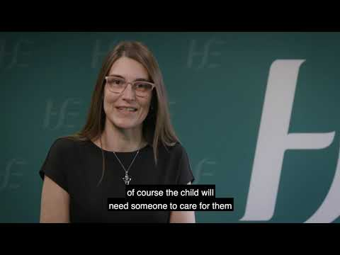

If your child is told to isolate from other people:

<https://www2.hse.ie/conditions/coronavirus/children-and-covid-19/if-your-child-is-told-to-isolate-from-other-people.html>

Testing for Children:

<https://www2.hse.ie/conditions/coronavirus/children-and-covid-19/testing-for-children.html>

# Appendix 5: Wellbeing Links

**WELLBEING LINKS FOR PARENTS**

**(Please press Ctrl and click the link to be brought to any of these documents on our Parents SharePoint.)**

1. **Directory Online Supports - Primary School - Updated Phase 3 January 2021**

<https://conventpschoolmallow.sharepoint.com/:b:/s/Covid19InformationforParentsGuardians/EfeGfsdBQiVFkbX-DXq8wfIBerRdtGvX2-h-z4YQXugMhg?e=cLgDZX>

1. **Advice for Parents while Schools are closed**

<https://conventpschoolmallow.sharepoint.com/:b:/s/Covid19InformationforParentsGuardians/EUJfPL3LBEZJra0Y9Yxlgg0Bq_RuZrHzWYUKcsza6ndH2Q?e=L8e8d7>

1. **Managing Stress and Anxiety: A Guide for Parents and Guardians**

<https://conventpschoolmallow.sharepoint.com/:b:/s/Covid19InformationforParentsGuardians/EeSpm1MypThGucfs7Py7by0BmXHcUnadQr1Nj6Y_UlIlGA?e=efLbex>

1. **How to Calm and Support your Child: Advice for Parents and Guardians**

<https://conventpschoolmallow.sharepoint.com/:b:/s/Covid19InformationforParentsGuardians/EUWrej3ZJYdMncTc2D-gbBEBpMHckSvb3sujI7VnwCrBBA?e=ElYJ98>

1. **Blank Plan for the Day**

<https://conventpschoolmallow.sharepoint.com/:b:/s/Covid19InformationforParentsGuardians/EQdjqWDBIAdFqPTdkX_YSO8BlQDye5yykBs6DXcmrrv00A?e=RLA70d>

1. **6. A Parent's Guide to Close Contacts in School - HPSC**

<https://conventpschoolmallow.sharepoint.com/:b:/s/Covid19InformationforParentsGuardians/EQ1ZdUZAXR5Jk8nEVfibXowB5jpJ4CtZK0e53_vVp7Wx2A?e=ttd6ux>

1. [**Parents Guide Supporting your child's daily routine while schools are closed**](https://youtu.be/jYdNzUo9m4Q)

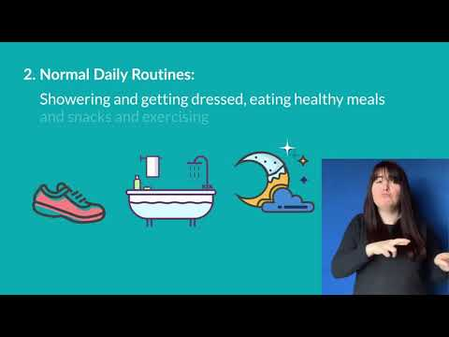

1. [**Tips for parents on supporting daily routines**](https://youtu.be/Ro1Q_LNWbsU)

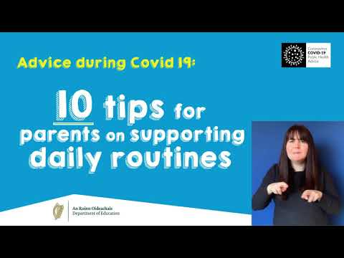

1. [**https://www.gov.ie/en/publication/af24b-wellbeing-guidance-documents-for-parents-students-and-schools/#parents-primary-schools**](https://www.gov.ie/en/publication/af24b-wellbeing-guidance-documents-for-parents-students-and-schools/#parents-primary-schools)
2. [**Back to school advice for parents**](https://youtu.be/03RXGM1hMMI)

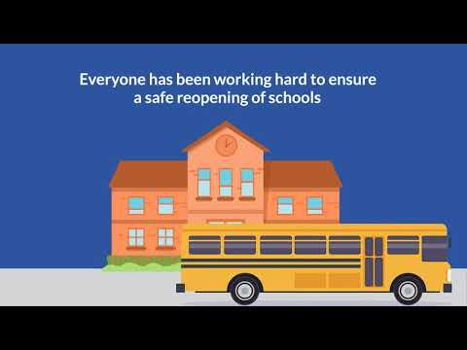

**WELLBEING LINKS FOR STUDENTS**

**(Please press Ctrl and click the link to be brought to any of these documents on our Parents/Students SharePoint.)**

1. **Advice for Young People while Schools are closed**

<https://conventpschoolmallow.sharepoint.com/:b:/s/Covid19InformationforParentsGuardians/Ecwj781-tYpDuFajnM9HWDAB0hKs90-jRoc2lbGsnm8yTA?e=bRm41a>

1. **Managing Thoughts and Feelings – A Guide for Students**

<https://conventpschoolmallow.sharepoint.com/:b:/s/Covid19InformationforParentsGuardians/EdFB6yY-wnpEgXvH-XuSrBkB3ltZq87Pl5Umn7EpyDdt3g?e=ty05I4>

1. **Managing Stress and Anxiety – A Guide for Students**

<https://conventpschoolmallow.sharepoint.com/:b:/s/Covid19InformationforParentsGuardians/Ec8rLvNaybxMmbFC7X7XwDsBgyYH2NIJjhAqYueJ1H2Psw?e=sdCp6T>

1. **Panic Attacks: A Guide for Students**

<https://conventpschoolmallow.sharepoint.com/:b:/s/Covid19InformationforParentsGuardians/EZ9caL-fqjxNrnusgk9FNHkBwPuSfvj7WysiUIZmVZUgLw?e=OiCzkv>

1. **Relaxation techniques**

<https://conventpschoolmallow.sharepoint.com/:b:/s/Covid19InformationforParentsGuardians/ETjvP9wnT_dBj0IqSKHhrf8BgDg2iD8IPKqGFZhww7fthw?e=GWQXIr>

1. **Blank Plan for the Day**

<https://conventpschoolmallow.sharepoint.com/:b:/s/Covid19InformationforParentsGuardians/EaapsTpkf0RFm6DakVd3_9sBIWezMMWBpoF4Yns1vrkshA?e=ixYX98>

1. [**Stay active and connected**](https://youtu.be/YqXqfMVD-_g)

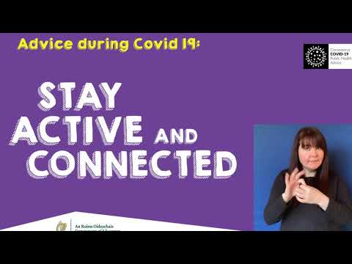

1. [**Stay positive and informed**](https://youtu.be/YI0ckF2xUv8)

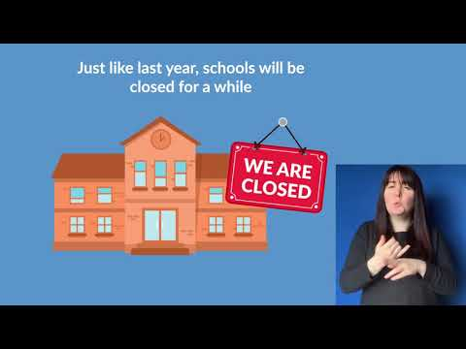

1. [**Relaxation techniques (podcast)**](https://soundcloud.com/user-719669409/relaxation-techniques-30-03-2020)

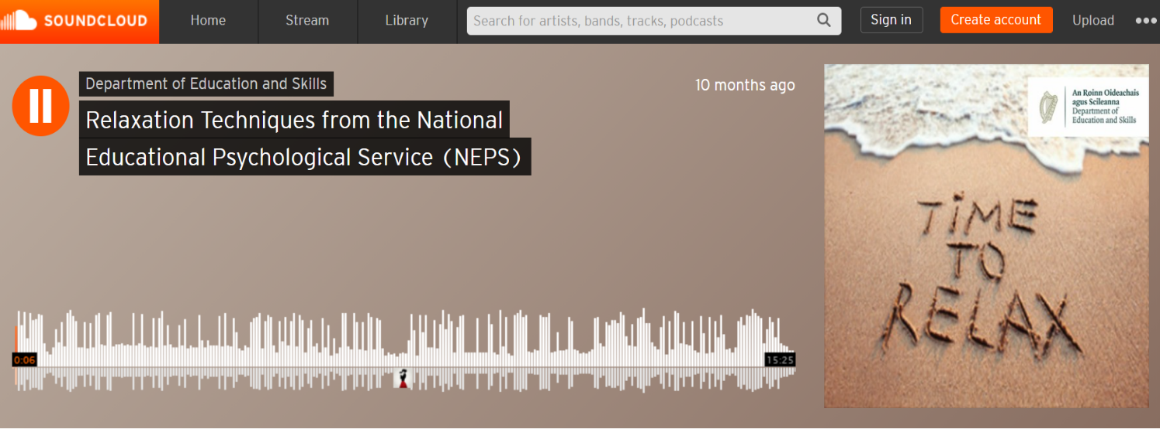

<https://soundcloud.com/user-719669409/relaxation-techniques-30-03-2020>

1. [**Back to school advice for junior infants to second class**](https://youtu.be/92MLB_0nq8Q)

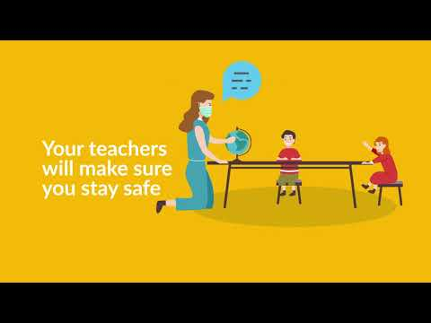

1. [**Back to school advice for 3rd to 6th class**](https://youtu.be/MVlb0jAm55Y)

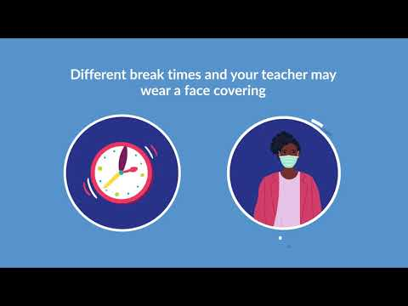

**WELLBEING LINKS FOR STAFF**

|  |
| --- |
| **Wellbeing Covid 19 documents Summarised for Staff**  **(Please press Ctrl and click the link to be brought to any of these documents on SharePoint.)** |
| **1.** ***Directory of Wellbeing Supports and Resources for Primary School Parents***  This is a list of supports and resources available for parents. In the document parents can click on underlined sections for further information on resources and services, including links to NEPS, HSE Health Promotion for School, PDST, NCSE, Gov.ie/in this together.  <https://conventpschoolmallow.sharepoint.com/:b:/s/ConventPrimarySchool/EUsnh99QyTlPj7mv7IEOQREB-Wv_XlYBLXZ_5a5RwTY5Hg?e=mbHwCn> |
| **2.**  ***Managing Stress and Anxiety- A Guide for Students***  Here are some tips on how pupils can manage any stressful or anxious thoughts or feelings as they settle into their new routine.  <https://conventpschoolmallow.sharepoint.com/:b:/s/ConventPrimarySchool/EYSzRdZleftHtH2-ozrU6dIBLHphsgXiD1PVQtmRblGZKQ?e=t13yN9> |
| **3.** ***Normalising Thoughts, Feelings and Behaviours - A Guide for School Staff***  If students have become stressed and anxious during this time the information in this document may be helpful.  <https://conventpschoolmallow.sharepoint.com/:b:/s/ConventPrimarySchool/EXl5C2Oy8w1HiqaE712IJMEBfP84NTcQLVwQEY7L9O2a6w?e=KD1UkG> |
| **4.**  ***Panic Attacks - A Guide for School Staff***  If students are becoming more and more stressed and fearful during this time the following information may be helpful. I particularly like the NEPs ‘Thoughts Log’ template at the end of this document allowing students to list ‘Helpful and Unhelpful thoughts.’  <https://conventpschoolmallow.sharepoint.com/:b:/s/ConventPrimarySchool/EWkgJ1Z43ZpJtJBUKbFhdukBEp8Mfy978N529tExSLY9rA?e=KS5fRG> |
| **5. *Responding to Critical Incidents during School Closures and Public Health Restrictions arising from COVID-19***  The purpose of this booklet is to outline how schools might adapt their response to critical incidents during the pandemic. I like that short-term and medium–term actions and follow ups are listed very clearly to follow. There are excellent resources and links at the end of this document particularly for parents sharing sad news with their child.  <https://conventpschoolmallow.sharepoint.com/:b:/s/ConventPrimarySchool/Ed2zP6MppxRNmzD0TdYufLkBTC0xSpYuhXx4s7BXNRGESA?e=DEttcA> |
| **6.** ***School Staff Wellbeing & Self-Care***  The aim of this guidance document is to provide some useful pointers to school staff on protecting their own wellbeing.  I particularly like Appendix 1. A template to reflect on how you are presently managing and caring for your wellbeing and how you can set some short-term or long-term goals to promote your resilience and wellbeing  <https://conventpschoolmallow.sharepoint.com/:b:/s/ConventPrimarySchool/ER5sg3SZdTBJqk4MGA1CEHcBult9032s_7zoob42hmHGQw?e=SK59q6> |
| **7. *Self-Regulation for Pupils - A guide for school staff***  As teachers, there are a number of things you can do to support pupils who may be feeling anxious or stressed. The Regulate, Relate, Reason Model is a useful model to draw upon from this document. There are 3 very good templates at the end of this document, including a Problem-solving Plan, a suggested script and a Mindfulness and Relaxation document.  <https://conventpschoolmallow.sharepoint.com/:b:/s/ConventPrimarySchool/EcLo83EZLLNEkZHi46PsGl8BrHJ3pDNhma2vPnia6mrKCQ?e=cTirJ3> |
| **8.** ***Supporting bereaved students and staff returning to school following Covid 19 and public health restrictions***  The purpose of this booklet is to advise school staff how best to support bereaved students and colleagues on their return to school following COVID-19 restrictions. The document is nicely broken into time periods…… ‘The first few days’ & ‘As time goes on - Showing compassion and Understanding.’  <https://conventpschoolmallow.sharepoint.com/:b:/s/ConventPrimarySchool/ES2ICKbKEThMq9Ux3LRqJGIBAjln4COQB8_5vLhCwwrq9Q?e=tjKOvE> |
| **9.** ***Supporting the Wellbeing of Students with Special Educational Needs (SEN) Returning to School***  Resources have been collated by Psychologists from NEPS to assist teachers & SNAs in tailoring transition supports to meet the needs of students with SEN, including students with autism, who are returning to school. There is a good section on ‘Reluctance to Return to School during COVID19’ and pg. 19 onwards has child friendly resources called ‘Going Back to School – Let’s Get Ready!’  <https://conventpschoolmallow.sharepoint.com/:b:/s/ConventPrimarySchool/EWFZAQbpSGdDpX4Pww5MQM8BXo6Oo_oTQ53hhzcrEUAanw?e=NcgTAI> |
| **10.** ***The Response to Stress Information for School Staff***  *This is a really interesting document discussing stress. It details stress types from ‘Positive Stress’, ‘Tolerable Stress’ & ‘Toxic Stress.’ It also provides us with a very valuable* Appendix 1 showing us strategies to Regulate, Relate and Reason (for ourselves and others.)  <https://conventpschoolmallow.sharepoint.com/:b:/s/ConventPrimarySchool/EXwQMuvw_p1NtFAcDKFZR8gBvFUuHYlK9ksql6dDYDpT3w?e=nWOeu7> |
| **11.** ***Wellbeing Supports and Resources for Primary Schools January to June 2021***  This directory outlines wellbeing supports and resources for primary schools during phase 3: January 2021 to end of academic year  In the document you can click on underlined sections for further information on resources and services, including links to NEPS, CSL, SSE of Wellbeing using the new Wellbeing Framework, EAS, HSE Health Promotion for School, PDST, NCSE, NCCA, RSE, SPHE and CPD Seminars.  <https://conventpschoolmallow.sharepoint.com/:b:/s/ConventPrimarySchool/ERDkIPhX3CJFmGngxwHXHl8B3OC_KFEPTUz9tnKzq-Cg3Q?e=TJopfs> |
| **12.** ***Supporting the Wellbeing of the School Community: Returning to School after Covid-19 School Closure***  Here is a very comprehensive 105-page Wellbeing Toolkit for Primary Schools. Most things in this Toolkit I already have separated out into the links above.  <https://conventpschoolmallow.sharepoint.com/:b:/s/ConventPrimarySchool/EfBQUC9M0GBJg8E_lizL-wMB7BwAJsfxw0_5yMy70ebQYg?e=Mq1gfc> |

1. [**Primary Schools Wellbeing Webinar**](https://youtu.be/o1t-4O23kKY)

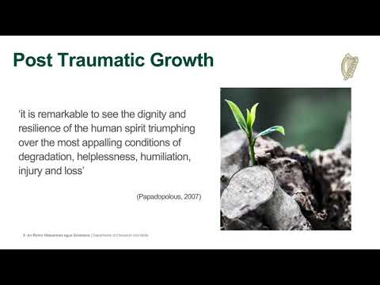

# Appendix 6 Checklist for School Management Composite Checklist for Schools

This checklist supports planning and preparation, control measures and induction needed to support a safe return to school for pupils, staff, parents and others. For completion by the agreed person with overall responsibility of managing the implementation of the COVID- Response plan in line with the supports as agreed with Department of Education.

|  |  |  |
| --- | --- | --- |
| **Planning and Systems** | **Yes** | **No** |
| 1. Is there a system in place to keep up to date with the latest advice from Government and Department of Education, to ensure that advice is made available in a timely manner to staff and pupils and to adjust your plans and procedures in line with that advice? |  |  |
| 1. Have you prepared a school COVID- response plan and made it available to staff and pupils? Department guidance and templates provided |  |  |
| 1. Have you a system in place to provide staff and pupils with information and guidance on the measures that have been put in place to help prevent the spread of the virus and what is expected of them? |  |  |
| 1. Have you displayed the COVID- posters in suitable locations highlighting the signs and symptoms of COVID-? |  |  |
| 1. Have you told staff of the purpose of the COVID- contact log? |  |  |
| 1. Have you a COVID- contact log in place to support HSE tracing efforts if required? |  |  |
| 1. Have you informed staff on the measures and provided a system for them to raise issues or concerns and to have them responded to? |  |  |
| 1. Have you reviewed and updated risk assessments in line with DES advice to take account of any controls to help prevent the spread of COVID-? (Risk template attached) |  |  |
| 1. Have you updated emergency plans, if necessary, to take account of the COVID- response plan? |  |  |
| **Staff** |  |  |
| 1. Have you made available to each staff member a COVID- return-to-work form to be completed and returned before they return to the workplace? (Template attached) |  |  |
| 1. Have you request confirmation that the details in the Return-to-Work Form remain unchanged following periods of closure such as school holidays. |  |  |
| 1. Are you aware of staff members who are at very high risk under the HSE guidance on people most at risk (HSE guidance on people most at-risk) and advised them of the DES agreed arrangements for management of those staff? |  |  |
| 1. Have you advised staff and pupils they must stay at home if sick or if they have any symptoms of COVID-? |  |  |
| 1. Have you advised staff and pupils not to return to or attend school if they are identified by the HSE as a close contact of a confirmed case of COVID- or if they live with someone who has symptoms of the virus? |  |  |
| 1. Have you advised staff and pupils not to return or attend school if they have travelled outside of Ireland; in such instances staff are advised to consult and follow latest Government advice in relation to foreign travel. |  |  |
| 1. Have you told staff and pupils what to do and what to expect if they start to develop symptoms of COVID- in school, including where the isolation area is? |  |  |
| 1. Have you advised staff and pupils to cooperate with any public health officials and the school for contact tracing purposes and follow any public health advice in the event of a case or outbreak in the school; |  |  |
| 1. Have you advised staff of the availability of the supports of the occupational health and wellbeing programme through Spectrum Life? |  |  |
| 1. Has a lead worker representative been identified (in line with the process agreed with the DES and education partners) and detailed at Section of this plan to help advise staff and to monitor compliance with COVID- control measures in the school and taken measures to ensure all staff know who the representative is? |  |  |
| **Training and Induction** |  |  |
| 1. Have you advised staff to view the Department of Education’s training materials which are available online? |  |  |
| 1. Have you taken the necessary steps to update your school induction / familiarisation training to include any additional information relating to COVID- for your school? |  |  |
| 1. Have first aiders, if available, been given updated training on infection prevention and control re: hand hygiene and use of PPE as appropriate? |  |  |
| **Buildings / Equipment** |  |  |
| 1. If you have mechanical ventilation, does it need cleaning or maintenance before the school reopens after periods of closure? |  |  |
| 1. Does your water system need flushing at outlets following low usage to prevent Legionnaire’s Disease? |  |  |
| 1. Have you visually checked, or had someone check, all equipment in the school for signs of deterioration or damage before being used again? |  |  |
| 1. Have you arranged for the school, including all equipment, desks, benches, doors and frequent touched surfaces points, to be cleaned once a day? |  |  |
| **Infection Prevention Control Measures in place Hand / respiratory hygiene** |  |  |
| 1. Have you accessed supplies of hand sanitisers and any necessary PPE equipment in line with the interim HPSC health guidance from the national framework provided by the Department? |  |  |
| 1. Are there hand washing/hand sanitising stations in place to accommodate staff, pupils and visitors adhering to hand hygiene measures in accordance with Department guidance? |  |  |
| 1. Have arrangements been made for staff and pupils to have regular access to handwashing/hand sanitising facilities as appropriate? |  |  |
| 1. Are hand sanitisers easily available and accessible for all staff, pupils and visitors – e.g. in each classroom and at entry and exit points to school buildings? |  |  |
| 1. Have you made arrangements to ensure hand hygiene facilities are regularly checked and well-stocked? |  |  |
| 1. Does the alcohol-based hand sanitiser have at least % ethanol or % isopropanol as the active ingredient? |  |  |
| 1. Have you informed staff about the importance of hand washing? |  |  |
| 1. Have you arranged for staff to view how to wash their hands (with soap and water for at least seconds) and dry them correctly through the use of the HSE video resource? |  |  |
| 1. Have you shown staff and pupils how to use hand sanitiser correctly and where hand sanitising stations are located? |  |  |
| 1. Have you displayed posters on how to wash hands correctly in appropriate locations? |  |  |
| 1. Have you told staff and pupils when they need to wash their hands or use hand sanitiser? This includes: |  |  |
| * 1. before and after eating and preparing food |  |  |
| * 1. after coughing or sneezing |  |  |
| * 1. after using the toilet |  |  |
| * 1. where hands are dirty |  |  |
| * 1. before and after wearing gloves |  |  |
| * 1. before and after being on public transport |  |  |
| * 1. before leaving home |  |  |
| * 1. when arriving/leaving the school /other sites |  |  |
| * 1. when entering and exiting vehicles |  |  |
| * 1. after touching potentially contaminated surfaces |  |  |
| * 1. if in contact with someone displaying any COVID- symptoms |  |  |
| 1. Have you told staff and pupils of the importance of good respiratory measures to limit the spread of the virus? |  |  |
| * 1. avoid touching the face, eyes, nose and mouth |  |  |
| * 1. cover coughs and sneezes with an elbow or a tissue |  |  |
| * 1. dispose of tissues in a covered bin |  |  |
| **Physical Distancing:** |  |  |
| 1. Have you identified all available school space to be used to maximise physical distancing? |  |  |
| 1. Have you reviewed the templates provided by the Department of Education which show options for revised layout of school rooms to meet physical distancing requirements? |  |  |
| 1. Have you arranged to revise the layout of the rooms and furniture as per the Department guidelines if necessary? |  |  |
| 1. Have you arranged in each room that the teacher’s desk should be at least m and where possible m away from pupil desks? |  |  |
| 1. Have you arranged in each room that pupils would be at least m away from each other? |  |  |
| 1. Have you allocated work stations consistently to the same staff and children rather than having spaces that are shared? |  |  |
| 1. Have you structured pupils and their teachers into Class Bubbles (i.e. a class grouping which stays apart from other classes as much as possible) and discrete groups or “Pods” within those class bubbles to the extent that this is practical? |  |  |
| 1. If you have divided a class into Pods, have you arranged at least m distance between individual Pods within the class bubble and between individuals in the pod, whenever possible? |  |  |
| 1. Have you taken steps to limit contact and sharing of common facilities between people in different Class Bubbles (and Pods within those class bubbles) as much as possible? |  |  |
| 1. Have you arranged Pod sizes to be as small as it is likely to be reasonably practical in the specific classroom context? |  |  |
| 1. Have you arranged to the greatest extent possible for pupils and teaching staff to be consistently in the same Class Bubbles acknowledging that this will not be possible at all times? |  |  |
| 1. Have you arranged where possible that different class bubbles to have separate breaks and meal times or separate areas at break or meal times? |  |  |
| 1. Have you made arrangements to limit interaction on arrival and departure from school and in other shared areas? |  |  |
| 1. Have you encouraged walking or cycling to school as much as possible? |  |  |
| 1. Have you made arrangements, in so far as practicable, to open additional access points to school to reduce congestion? |  |  |
| 1. Can you provide a one system for entering and exiting the school, where practical? |  |  |
| 1. Have you arranged for staff meetings to be held remotely or in small groups or in large spaces to facilitate physical distancing? |  |  |
| 1. Have you a system to regularly remind staff and pupils to maintain physical distancing? |  |  |
| 1. Have you advised staff not to shake hands and to avoid any physical contact? |  |  |
| 1. Have you advised staff of the Department’s guidance to achieve good ventilation? |  |  |
| 1. Have you checked any mechanical ventilation systems to ensure an adequate supply of fresh air is used? |  |  |
| **Visitors to Schools** |  |  |
| 1. Have you identified the activities that involve interacting with essential visitors to the school, made arrangements to minimise the number of such visitors and put in place measures to prevent physical contact, as far as possible? |  |  |
| 1. Are there arrangements in place to inform essential visitors to the school of the measures to help prevent the spread of infection? |  |  |
| 1. Have you a system in place for all visitors who do need to come to the school to make appointment, arrange to contact a central point and to record their visit using the contact tracing log? |  |  |

# Appendix 7 Checklist for dealing with a suspected case of COVID-19

Staff members will be required to manage a suspected case in line with the protocol and training. A nominated member of the school management team will be nominated as the designated contact person for ensuring that all aspects of the protocol to deal with suspected cases have been adhered to.

|  |  |  |
| --- | --- | --- |
| **Isolation Area** | **Yes** | **No** |
| 1. Have you identified a place that can be used as an isolation area with a door that can close? |  |  |
| 1. Does the isolation area cater for people to be 2m away from others in the room? |  |  |
| 1. Is the isolation area accessible, including to staff and pupils with disabilities? |  |  |
| 1. Is the route to the isolation area accessible? |  |  |
| 1. Have you a contingency plan for dealing with more than one suspected case of COVID-19? |  |  |
| 1. Are the following available in the isolation area(s)? |  |  |
| * 1. Tissues |  |  |
| * 1. Hand sanitiser |  |  |
| * 1. Disinfectant/wipes |  |  |
| * 1. Gloves/Masks |  |  |
| * 1. Waste Bags |  |  |
| * 1. Bins |  |  |
| **Isolating a Person** |  |  |
| 1. Are procedures in place to accompany the infected person to the isolation area, along the isolation route with physical distancing from them? |  |  |
| 1. Are staff familiar with this procedure? |  |  |
| 1. Have others been advised to maintain a distance of at least 2m from the affected person at all times? |  |  |
| 1. Is there a disposable mask to wear for the affected person while in the common area and when exiting the building? |  |  |
| **Arranging for the affected person to leave the school** |  |  |
| 1. Staff – have you established by asking them if the staff members feel well enough to travel home? |  |  |
| 1. Pupil – have you immediately contacted their parents/guardians and arranged for them to collect their pupil? |  |  |
| 1. Has the affected person should be advised to avoid touching other people, surfaces and objects? |  |  |
| 1. Has the affected person been advised to cover their mouth and nose with disposable tissue(s) when they cough or sneeze, and to put the tissue in the bin? |  |  |
| 1. Has transport home or to an assessment centre been arranged if the affected person has been directed to go there by their GP? |  |  |
| 1. Has the affected person been advised not to go to their GP’s surgery or any pharmacy or hospital? |  |  |
| 1. Has the affected person been advised they must not use public transport? |  |  |
| 1. Has the affected person been advised to continue wearing the face mask until the reach home? |  |  |
| **Follow up** |  |  |
| 1. Have you carried out an assessment of the incident to identify any follow-up actions needed? |  |  |
| 1. Are you available to provide advice and assistance if contacted by the HSE? |  |  |
| **Cleaning** |  |  |
| 1. Have you taken the isolation area out-of-use until cleaned and disinfected? |  |  |
| 1. Have you made arrangements to clean and disinfect any classroom space where the staff or pupils were located? |  |  |
| 1. Have you arranged for cleaning and disinfection of the isolation area and any other areas involved, as soon as practical after the affected person has left the building? |  |  |
| 1. Have the cleaners been trained in dealing with contaminated areas and supplied with the appropriate PPE? |  |  |

# Appendix 8 Checklist for Cleaning

Have you a system in place for checking and keeping up to date with the latest public health advice from Government and the Department of Education, to ensure that advice is made available in a timely manner in order to adjust your cleaning procedures in line with that advice?

|  |  |  |
| --- | --- | --- |
|  | Yes | No |
| 1. Have you reviewed the HPSC interim health advice for the safe reopening of schools, in particular Section 5.6 Environmental Hygiene? |  |  |
| 1. Have you explained the need for the enhanced cleaning regime to staff? |  |  |
| 1. Are you aware that cleaning is best achieved using a general-purpose detergent and warm water, clean cloths, mops and the mechanical action of wiping and cleaning, following by rinsing and drying? |  |  |
| 1. Have you sufficient cleaning materials in place to support the enhanced cleaning regime? |  |  |
| 1. Have you provided training for cleaning staff on the enhanced cleaning regime? |  |  |
| 1. Have you made arrangements for the regular and safe emptying of bins? |  |  |
| 1. Are you familiar with the cleaning options for school settings set out in the interim HPSC health advice for schools for surfaces, toilets, cleaning equipment, PPE and waste management? |  |  |
| 1. Are you aware that each school setting should be cleaned once per day? |  |  |
| 1. Have you provided cleaning materials to staff so that they can clean their own desk or immediate workspace? |  |  |
| 1. Have you advised staff that they are responsible for cleaning personal items that have been brought to work and are likely to be handled at work or during breaks (for example, mobile phone and laptops) and to avoid leaving them down on communal surfaces or they will need to clean the surface after the personal item is removed? |  |  |
| 1. Have you advised staff and pupils to avoid sharing items such as cups, bottles, cutlery, and pens? Have you put in place a written cleaning schedule to be made available to cleaning staff including: |  |  |
| * 1. Items and areas to be cleaned |  |  |
| * 1. Frequency of cleaning |  |  |
| * 1. Cleaning materials to be used |  |  |
| * 1. Cleaning of frequently touched surfaces such as vending machines, coffee machines and door handles |  |  |
| * 1. Equipment to be used and method of operation? |  |  |
| 1. Details of how to clean following a suspected case of COVID-19 are at Section 7 of the Plan above 1 |  |  |
| 1. If disinfection of contaminated surfaces is required, is a system in place to do this following cleaning? |  |  |
| 1. If cleaning staff have been instructed to wear gloves when cleaning are they aware of the need to wash their hands thoroughly with soap and water, both before and after wearing gloves? |  |  |
| 1. Have you a system in place for disposing personal waste such as cleaning cloths and used wipes in a rubbish bag? The Protocol advises that personal waste such as cleaning waste, tissues etc. should be double bagged and stored in a secure area for 72 hours before being presented for general waste collection. |  |  |
| 1. Have you ensured there is a system in place to make sure reusable cleaning equipment including mop heads and non-disposable cloths are clean before re-use? |  |  |
| 1. Have you ensured there is a system in place to ensure that equipment such as buckets are emptied and cleaned with a fresh solution of disinfectant before re-use? |  |  |